THEORY QUESTIONS

PART I

MAP SKILLS AND THE ENVIRONMENT
1.
a)

Write notes on contours and illustrate with diagrams
i)

a valley
ii)

a ridge
iii)

plateau
iv)

conical hill
b)

How are the following features shown on topographical maps
i)

railway line
ii)

a bridge
iii)

farm
iv)

footpath
v)

an area liable to flood

2.
Use the map below to answer the Question below
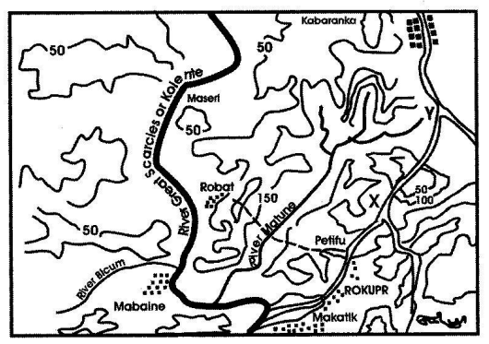
a)

i)

What is the name of the major river shown on the map?
ii)

What is the main tributary of this river?
b)

i)

Measure the distance from X to Y in kilometers (Scale = 1cm : 2km)
ii)

Which type of road is from Rokupr to Kabaranka?
c)

i)

Which type of settlement is at Kabaranka?
ii)

What is the height of Maseri in feet?

PART II

NATIONAL COMMUNITY
3.
What are the importance of festivals in Ghana?

4.
Write an essay on one of the following:
a)

The achievements of Dr Kwame Nkrumah
b)

The achievements of Sir Gordon Guggisberg

PART III

WEST AFRICA, AFRICA AND THE WORLD
5.
What four major benefits do West Africans derive from their rivers? Give specific examples where necessary.

6.
Problems facing the Organization of African Unity (OAU)

